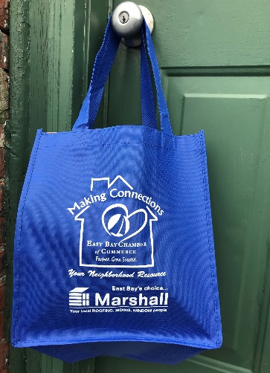
Making Connections Program

HOW IT WORKS: Each month we will hand deliver a Making Connections bag to new homeowners filled with your promotional items. Here’s the best part: You will receive the list of names and addresses of the homes that we delivered to so that you can continue reaching these homeowners through your own marketing efforts.

TO PARTICIPATE:
Participate one full year $500. You supply 1200 promotional pieces.
Participate 6 months, $300. You supply 600 promotional pieces.
Participate 3 months $150. You supply 600 promotional pieces.
We collate into the bags each month and deliver to the homeowners. Be creative. For most recipients this will be there first introduction to your business!
Promotional materials must be in the Chamber office before the last Monday of the month.
YES! Please Sign Me Up! I have circled the program I would like to participate in.
Business Name: ___________________________________________________
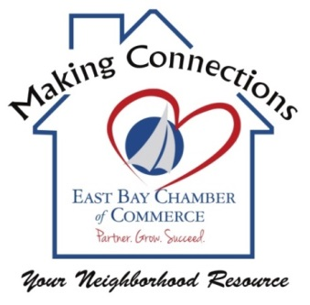
Address: _________________________________________________________
Phone: ________________________Email:_____________________________
Business Representative: ___________________________________________
Signature: _______________________________________________________
Promotional item: __________________________________________________
Thank you to our Sponsor:
Fax 245-0110, email info@eastbaychamberri.org or mail form back to
East Bay Chamber, 16 Cutler St., Suite 102, Warren, RI 02885
You MUST be a member in good standing. If you cancel your membership before your "Making Connections"
Contract is up you will not receive a refund for the program
You are responsible for having your promotional items in before the drop deadline. There will be NO exceptions.
If your item is not at the Chamber office by the deadline, the bags will go out and you will not get a refund
for that month. You will be added to the bags for the rest of the time period of your contract.

